People and Work Unit

“I want some of that”

Trailblazers and Learning Brokers in the South Wales Valleys

A study funded by the Welsh Assembly Government’s New Ideas Fund

Duncan Holtom

November 2007

32 Monmouth Road
Abergavenny
Monmouthshire
NP7 5HL

Tel: 01873 850975
Fax: 01873 855190
E-mail: peoplework@btconnect.com

Uned Pobl a Gwaith

Acknowledgements

Thanks are extended to the Welsh Assembly Government for funding this study. We could not have undertaken the study without the help of Susan Barrow, Eddie Baldacino, Helen Boggis Steve Brookman, Rhys Burton, Les Davies, Gary Foreman, Jeremy Gass, Tina Griffin, Darren Lewis, Suzanne Marchment, Wayne Morris, Tim Palazone, Theresa Parsell, Katy Hollings, Claire Syder, Mike Williams, Tefor Willaims, ten key informants, 11 interviewees and the 232 learners who completed questionnaires. Thanks are also extended to Rhodri Bowen, Alison Bryant, Sarah Lloyd-Jones and Tamlyn Rabey for their comments on this and earlier papers and to Rhodri Bowen, Gillian Snelgrove, Nesta Watkins and Adrian Watkins, for their help designing, distributing and managing responses to the questionnaire.
Executive Summary

In section one we briefly sketch out the scale of the challenge facing Wales in terms of raising adult participation in learning and review some of the literature on the factors that shape the formation of negative “learner identities” (Gorard & Rees, 2002). We outline the potential role of learning brokers who can catalyse re-engagement in learning and consider three types of learning brokerage: a formal model, involving professionals, such as careers advisers, whose role includes brokering access to learning; a more informal model, where for example, friends and family encourage someone to take up a learning opportunity and passive model, in which the success of learners inspires others to consider learning themselves.

In section two we discuss the methodology, including a survey of over 800 learners in campus and community based further and higher education and interviews with ten key informants, ten learners and a facilitated focus group with eleven learners. The survey included a wide range of learners, but the interviews and focus groups focused in particular upon disadvantaged areas. We highlight the limitations of the study, including the low response rate to the survey of learners in community and campus based further education, which limit the conclusions that can be drawn from it, if considered in isolation. However, when the results of both surveys can be triangulated with findings from the interviews, focus group and wider literature, we can have more confidence in their validity and their applicability to the wider population.

In section three we discuss the profile of respondents to the survey of learners in community and campus based further education, noting aspects such as the female bias and the 50/50 split between those with no qualifications or qualifications below NQF Level 2 and those with qualifications at and above NQF Level 2.

In section four we discuss the findings from the survey, including the evidence of the importance of informal brokerage by those close to respondents: parents, partners and friends and the lesser, but still noteworthy, importance of more formal brokers, such as Careers Wales Advisers. We find that roughly two thirds of respondents had a positive learner identity; that the prospect of better paid and/or more rewarding work is a powerful motivation; and that although half of respondents expected to be supported by friends and family, a significant minority felt their partner or family might discourage them if they had problems. We also analyse results for those with negative learner identity and those with no or low qualifications and find intriguing evidence that suggests that they are less likely to identify encouragement or information provision by more formal brokers and more likely to identify informal learning brokerage from friends and family.

In section five we discuss the profile of respondents to the survey of learners in higher education, noting aspects such as the predominance of males (over 80%) and the relatively high levels of qualifications held by respondents (over two thirds have qualifications at or above NQF level 3).

In section six we discuss findings from the survey of learners in higher education. We find that the most important sources of encouragement were informal brokers such as parents, friends and partners and employers (a more formal broker), but note that a sizable proportion of respondents appear to have been motivated primarily by themselves rather than others. We find that a large majority of respondents reported characteristics associated with a positive learner identity and expected to be supported and encouraged by others.

We analysed the results of those who did not enjoy school to see if there were any notable differences compared to those who enjoyed school. We find that although encouraged by friends, family and partners, very few of those who had not enjoyed school identified that they had been encouraged or provided with information by more formal brokers. We also find that those who enjoyed school identified more people who had provided them with information.

We also analysed the results of female respondents separately. We find that they were more likely than male respondents to be encouraged by friends, their partner and their children, but less likely to be encouraged by their parents and less likely to be provided information by their friends and professional advisers.

In section seven we discuss findings from our interviews with key informants and our interviews and focus group with learners. We explore the importance of learning brokers in motivating their decisions to return to learning, noting a number of examples. We also consider the extent to which they have influenced others, again identifying a number of examples. We find that their success, in terms of salaries, status and access to rewarding jobs all motivate others, often through a relatively passive model of brokerage. We suggest that these successful learners can become trailblazers that inspire others to try to follow in their footsteps. We find this is most likely where successful learners are not only visible within the community, but are also considered credible by being sufficiently similar for other potential learners to identify with them.

However, we find that the ripple effect is limited by both access to opportunities and capacity to make effective use of those opportunities. We also find some evidence that in group situations, a learner’s success can actually de-motivate others by undermining their self-efficacy (belief in their own abilities to succeed). Moreover, although most learners’ partners and family were supportive, we find some evidence where they have discouraged learners.

In section eight we draw out the conclusions, structured around the research objectives. We conclude that there is evidence of a ripple effect operating through formal, informal and passive models of learning brokerage. We find that it spreads within groups in the community primarily by word of mouth, but note how this is limited by low stocks of bonding social capital, so that the spread of information about success between different groups can be limited. We find evidence in the surveys, interviews and literature, that friends, family and partners, may be particularly important for people in lower socio-economic groups. This suggests that more formal services have has less success reaching out to this group. This may be because this group is less motivated and less able to make effective use of their services.

Given our findings on sources of encouragement and the transmission of information, we suggest that in disadvantaged communities characterised by high levels of unemployment, economic inactivity and “poor work” and low levels of educational attainment and participation in post-16 education and training, the level of encouragement and information experienced by potential learners is likely to be less positive, more limited and more inaccurate than it is in more advantaged communities.

However, we find evidence that when people in disadvantaged communities see others they identify with succeed, this can create envy which can motivate them, provided they have access to opportunities and the capacity to make use of those opportunities. We suggest, therefore, that enabling people from disadvantaged community to succeed and raising their profile within the community could help create a ripple effect. We also find some evidence that more formal models of learning brokerage can be effective, but find that they are not always reaching non-traditional learners (traditionally regarded as ‘hard to reach’). In order to maximise the impact of the ripple effect and strengthen more formal models of learning brokerage, we recommend that consideration be given to:

- Raising the profile of local success stories;
- Investing in bridging social capital to bring different groups within the community together;
- Piloting a prospectus of local jobs (with information about the courses and qualifications needed to access them), rather than just courses;
- Exploring how the capacity and motivation of teachers and tutors to act as learning brokers could be enhanced;
- Investigating ways in which those who already have credibility in the eyes of learners could extend their credibility to other potential sources of advice and guidance;
- Strengthening collaboration between providers, so that providers are incentivised to broker access to other providers’ courses; and
- Ensuring that progression routes, support and encouragement are in place whenever and wherever a ripple effect is likely to occur.

1. Introduction

  - Raising adult participation in learning is central to the Welsh Assembly Government’s (WAG) economic development and social justice agendas (WAG, 2006). However, despite a significant investment in both provision and infrastructure (NIACE Dysgu Cymru, 2005), rates of participation in post-16 education and training have remained relatively static in the last 4 years and rates of participation amongst lower socio economic groups remain much lower that rates amongst higher socio-economic groups (Aldridge, et al, 2007).

  - Surveys of Adult Participation in Wales (Aldridge, et al, 2007; Aldridge & Horrocks, 2003), suggests that the key determinants of participation in learning include socio-economic class, prior education, age, gender, employment status and place. Whilst not determinative of people’s participation in post-16 education and training, these factors have been found to be strongly associated with different “learner trajectories”, embodied in the markedly different rates of participation of different groups of people. These factors can be used to predict, with a high degree of accuracy, whether someone will or will not participate in post-16 education and training (Gorard and Rees, 2002). Gorard, et al, (2006) suggest that:

One possible explanation for this remarkable finding is that family poverty, lack of role models, and a sense of ‘not for us’, coupled with poor experiences of initial schooling can act to create a kind of lifelong attitude to learning – a negative learner identity. (p. 26, ibid.)

  - This concept of a negative “learner identity” can encompass a range of interlinked and mutually reinforcing “dispositional barriers” to learning (McGivney, 2000, 1990) including a lack of belief in a individual’s ability to learn (low self-efficacy) (Cornwall, 1999; Bandura, 1997); a lack of faith in the value or importance of qualifications (Lloyd-Jones, 2005; McDonald & Marsh, 2005); and a set of familial and community norms and expectations that circumscribe participation in post-16 education and training (Bowman, et al, 2000).

  - There is some evidence that “learning brokerage”, where intermediaries, including both organisations and individual workers acting as “catalysts”, “brokers “or “change agents” for learning, can help engage those with negative learner identities in learning (Yarnit, et al, 2005; Thomas, et al, 2004). Learning brokers are now being deployed on a large scale through the work of partnerships such as the Community University of the Valleys (CUV) and RISE.

  - Although Learning brokerage is becoming increasingly professionalised, there is some evidence that more informal brokerage, such as encouragement from friends and family, can also be effective. For example, the 2003 NIACE Dysgu Cymru survey of Adult Participation in Wales (Aldridge & Horrocks, 2003), suggests that amongst those who have participated in learning in the last three years, the main sources of information about learning are employers (26%), College (15%), friends and family (14%), school (9%) and workmates and colleagues (8%). This indicates that over a fifth of current learners’ information comes informally via ‘word of mouth’ (friends and family plus workmates and colleagues).

  - There is also some anecdotal evidence that a more passive model of learning brokerage may operate, where the success of learners in communities where traditionally few people have succeeded in learning, creates a “ripple effect”. Their visibility in the community can provide tangible ‘proof’ that learning is both achievable and profitable, and this can challenge and begin to change the dispositional barriers to learning held by others in the community.

  - Although encouraging, the evidence of the effectiveness of these three, sometimes over-lapping, models of learning brokerage – formal, informal and passive, - is patchy and incomplete. It is not clear, for example, whether one model of learning brokerage is more important for some groups. As noted, overall, employers, workmates and colleges are important sources of information (ibid.), but it is quite possible that other sources, such as friends and family, will increase in importance for those who unemployed or economically inactive and who are not currently engaged in education or training.

  - Given the gaps in our knowledge, the aim of this study was to better understand the impact of educational role models in deprived communities in South Wales. The objectives were:

- To map how information about individual learners’ successes and failures spreads in the community including who hears about it, from whom, in what context and how accurate the information is;
- To assess how people respond to the successes and failures of existing learners, including an assessment of the influence of role models’ success upon their own attitudes and beliefs about learning;
- To understand the ripple effect, if there is one, and to identify possible preconditions for the ‘ripple effect’; and
- To identify how the impact, if any, of role models can be maximised.

  - The study was funded by the Welsh Assembly Government’s New Ideas Fund and we are grateful for the help of both learners and key informants who gave their time to support this study.

- Methodology

  - Overview: In order to provide a balance between depth and breadth, the research surveyed over 800 learners using a self completion questionnaire and interviewed ten key informants and ten learners and facilitated a focus group with 11 learners, who were considered potential role models.

  - Survey: In total, 825 questionnaires were distributed and 232 were returned. The overall response rate (28%) was low, even for a self-completion postal questionnaire (Bryman, 2004). There were however marked differences in the response rates from students at different institutions, with no responses received from two institutions that accounted for over a third of the questionnaires that were distributed (see table 1.1 below). If these two institutions, where there was no response, are excluded from the survey this would provide a 42% response rate from 525 questionnaires distributed.

Table 1.1. Response rates from different institutions
Organisation | # of questionnaires distributed | # of questionnaires returned | response rate (%)
University of Glamorgan | 195 | 172 | 88%
The Community University of the Valleys-East, Tredegar | 30 | 8 | 27%
Coleg Morgannwg | 250 | 45 | 18%
The Cana Centre | 30 | 5 | 16%
Catapult, Tredegar | 20 | 2 | 10%
Coleg Gwent | 250 | 0 | 0%
Bryncynon Community Revival Strategy. | 50 | 0 | 0%
Total | 825 | 232 | 28%

  - The response rate in the University of Glamorgan was probably much higher than in other institutions because questionnaires were distributed and collected in class. However, it is not clear why the response rates varied so much between the other institutions and why a significant proportion of respondents chose not to complete some sections. The survey followed best practice guidelines. The questionnaire was pre-tested, was deliberately kept short and simple and relied principally upon closed questions. It came with a clear introduction to the survey, and provided free-post envelopes.

  - Because the response rate was so much higher in the University of Glamorgan and because the responses were so different to the rest of the sample (see sections 3 and 5) we have analysed the results separately in order to avoid skewing the results.

  - In addition to the low response rate the survey was weakened by non-completion of sections of the questionnaire. The report therefore uses the number of responses rather than percentages in the tables and does not include graphs, because they could present a misleading picture because small changes in the number of respondents would be reflected in large changes in the percentage of respondents. However for the survey of learners at the University of Glamorgan, where the numbers of responses are higher, we make use of percentages and graphs to illustrate our findings.

  - Interviews: 21 learners living in the communities of Bryncynon, Ebbw Vale, Penywaun, Rassau, and Treherbert were interviewed or took part in focus groups. Their experiences were contextualised by interviews with ten key informants, people living and working in these communities. Key informants were chosen because it was felt they either had the potential to be role models who had influenced others in the community to return to learning or because their work in the community meant they would be well placed to understand its dynamics.

- Profile of respondents to the survey of learners in community and campus based further education

  - The respondents do not appear to be representative of the wider student body (see tables 2.1 to 2.5). Responses were biased toward part-time over full-time courses and females over males. Respondents were split roughly 50/50 between respondents aged above and below 25. Respondents were split roughly 50/50 between those with no qualifications or qualifications below National Qualifications Level (NQF) 2 (equivalent to 5 or more GCSEs or O-Levels grades A*-C) and those with qualifications at Level 2 or above. Respondents were split roughly 60/40 between those who were economically inactive and those who were economically active (employed or self-employed) (see tables 2.1 to 2.5).

  - Although not representative, the sample does include a relatively large number of respondents with no or low qualifications and young learners, who are both key target groups for the WAG (WAG, 2006).

Table 2.1. Type of course studied
 | Full time | Part time | No response
# of responses | 16 | 41 | 3

Table 2.2. Sex of respondents
 | Male | Female | No response
# of responses | 8 | 47 | 5

Table 2.3. Age of respondents
 | 15-16 | 17-18 | 19-24 | 25-44 | 45-64 | 65+ | Not completed
# of responses | 0 | 12 | 13 | 26 | 7 | 2 | 0

Table 2.4. Respondents’ Qualifications
 | No qualifications | Don’t know/can’t remember | NQF Level 1 | NQF Level 2 | NQF level 3 | NQF Level 4 and above | No response
# of responses | 7 | 4 | 17 | 22 | 7 | 2 | 1

Table 2.5. Respondents’ Status*
 | Employed Full time | Employed Part time | Student Full time | Student Part time | Self-employed | Looking for work | Voluntary work | Retired | Other | No response
# of responses | 6 | 15 | 9 | 8 | 6 | 6 | 6 | 3 | 3 | 7

* Totals are greater than 60 because some respondents ticked more than one box (e.g. employed and part time student)
- Survey of learners in community and campus based further education: Findings

  - Who influenced learners when deciding about participation in learning? The survey, (subject to the caveats discussed in paragraph 3.1.), suggests that the most important learning brokers tend to be informal and to be close to learners: parents, partners and friends (identified by 24, 22 and 17 respondents respectively as people who had “encouraged them”). This was reinforced by the relatively large number of respondents (9) who identified knowing people on the course as another important factor that encouraged them. Moreover only one respondent identified one of this group (their parents) as a negative influence, someone who had discouraged them (see table 4.1.). This was largely reflected in the written comments, which provided a number of examples where family, friends and partners in particular had encouraged learners. As one respondent commented:

My mother inspired me to go to college to get the qualifications needed to work with children, as this is the job I love to do. Also I needed the qualification in order to work as a nursery nurse.

  - However there was some suggestion from the written comments that when respondents had identified people who had “encouraged” them, this was often as much about support as about providing the inspiration to return to learning. For example, as one respondent put it:

My family have supported me during my 3 years of training. My son has been fantastic in understanding why I am training and my husband has supported me financially as well as supporting my decision to trainee to become a nursery nurse or playworker, which I am employed to do now. I wouldn’t or couldn’t continue to trainee for the 3 years if my family hadn’t supported me. I am so glad I chose to trainee to become a nursery nurse/ playworker now because I love my job and I have never been able to say that about a job before.

  - There was some evidence that more formal brokers, such as professional advisers, youth and community workers and teachers and tutors were also positive influences (identified by 5, 5 and 4 respondents respectively as people who had “encouraged them”). The written comments suggested that in many cases these brokers had not only supported people once they made the decision to return to learning, but had provided the catalyst to spark that inspired them. For example as three respondents put it in their written comments:

I attended a healthy living course at my daughters nursery school and I became friendly with Mrs [name omitted]. Mrs [name omitted] told me about the DCE course and she helped me apply for the course. I am now going into my 3rd and final year and in May/June 2008 I will become a qualified level 3 nursery nurse

I have thought about this for a while but didn’t have the confidence to do anything about it, but had a chat to a local nurse, who encouraged me to look into the access to health course. I then had a chat to the course tutor, which made me realise that the course was right for me.

I started as a dinner lady and really enjoyed working with children. I was inspired and encouraged by my mentor who has helped me. I am supported by my husband.

  - Markedly larger numbers of respondents identified more formal brokers, such as professional advisers, youth and community workers and teachers and tutors as people who had “provided information” (11, 4 and 13 respondents respectively).

  - In contrast, only four respondents identified negative influences, people who had discouraged them, including parents, employers, children and the job centre.

Table 4.1. Sources of encouragement and information
 | Encouraged me | Provided information | Discouraged me | Don’t know/ not relevant | No response
My friends | 17 | 4 | 0 | 10 | 29
My partner | 22 | 0 | 0 | 10 | 28
My parents | 24 | 0 | 1 | 16 | 29
My children | 6 | 0 | 1 | 18 | 35
My employer | 7 | 3 | 1 | 14 | 35
Teacher or tutor | 4 | 13 | 0 | 10 | 33
A professional adviser (e.g. Careers Wales, social worker, YOT worker) | 5 | 11 | 0 | 11 | 33
The Job Centre | 1 | 3 | 1 | 17 | 38
Someone based in my community (e.g. a youth or community worker) | 5 | 4 | 0 | 17 | 34
Knowing people on the course | 9 | 3 | 0 | 11 | 37
Knowing people at the centre/college | 4 | 6 | 0 | 14 | 36

  - Experiences of and attitudes toward learning: Roughly two thirds of respondents had a positive learner identity and just under a third had elements of a negative learner identity. Specifically, around two thirds of (40) respondents agreed or strongly agreed with the statement “I enjoyed school”, although a large minority, comprising almost a third of respondents (18) had not. Similarly, over two thirds (42) disagreed or strongly disagreed with the statement, “I find learning difficult”, with a fairly large minority (13) agreeing or strongly agreeing. Almost three fifths of respondents (48) disagreed or strongly disagreed with the statement: “Seeing my friends comes before my learning”. (see table 4.2.).

  - Motivations: Work and enjoyment emerged as the main motivations. A large majority (50) agreed or strongly agreed with the statement: “I am doing this course because I enjoy it “. A similarly large majority (49) agreed or strongly agreed with the statement “I need to complete this course for the work I want to do”. This was reinforced by the written comments made in response to the question “Who or what has inspired you to return to learning or to continue learning?” 26 of the 55 comments identified getting a better paid or more rewarding job as an important motivation. For example:

Me myself wanted to return to learning so I could have better job prospects in the future and a job I really enjoy and [i] am not just there for the money.

To gain skills and qualifications that I need to work with pre-school children.

Because I want a good career.

  - Almost half (27) agreed or strongly agreed with the statement: “I am doing this course to help my family”. (see table 4.2.). Written comments included:

I wanted to better my life and get a good job so that my family can be better off.

Having two children to provide for and ending up as a single mum inspired me to take action to better myself and provide a secure future for my children.

  - Support and encouragement: Over half of respondents expected to be supported by friends and family. Over two thirds of respondents (45) disagreed or strongly disagreed with the statement: “If I find the course stressful, my friends would encourage me to stop”. Similarly, over two thirds of respondents (45) agreed or strongly agreed with the statement: “It helped me that I knew people like me were doing this course”. A majority of respondents (36) agreed or strongly agreed with the statement: “When I am struggling with my course, my family or partner would help me”. Around half of respondents (31) agreed or strongly agreed with the statement: “My family accepts that sometimes being on this course disrupts family life”. As noted in paragraph 4.2. a number of written commented identified how family and partners had helped them.

  - However a significant minority fear discouragement from their partner or family. Over a quarter (16) disagreed or strongly disagreed with the statement: “When I am struggling with my course, my family or partner would help me”. Moreover, over a quarter of respondents (21) disagreed or strongly disagreed with the statement: “My family accepts that sometimes being on this course disrupts family life”. (see table 4.2.). In contrast to the positive examples of support and encouragement, none of the written comments provided examples of discouragement or the denial or withdrawal of support.

Table 4.2. Experiences of and attitudes toward learning | # of responses
Question | Strongly Agree | Agree | Do not know | Disagree | Strongly  Disagree | No response
I enjoyed school | 10 | 30 | 1 | 12 | 6 | 1
I have started lots of courses but not finished them | 1 | 3 | 0 | 22 | 30 | 4
Since I left school none of my friends have continued in education and training | 5 | 4 | 14 | 20 | 13 | 4
I find learning difficult | 0 | 7 | 6 | 22 | 20 | 5
Housework has to come before my learning | 1 | 3 | 4 | 29 | 17 | 6
When I am struggling with my course, my family or partner would help me | 14 | 22 | 4 | 12 | 4 | 4
I need to complete this course for the work I want to do | 34 | 15 | 1 | 7 | 1 | 2
If I find the course stressful, my friends would encourage me to stop | 3 | 2 | 6 | 23 | 22 | 4
My family accepts that sometimes being on this course disrupts family life | 9 | 22 | 4 | 15 | 7 | 3
Seeing my friends comes before my learning | 1 | 3 | 4 | 31 | 17 | 4
I am doing this course because I enjoy it | 32 | 18 | 3 | 3 | 0 | 4
It helped me that I knew people like me were doing this course | 24 | 21 | 10 | 2 | 0 | 3
I am doing this course to help my family | 9 | 18 | 1 | 17 | 8 | 7

  - Was encouragement more important for those who did not enjoy school? We analysed responses from the 18 respondents who disagreed or strongly disagreed with the statement “I enjoyed school”. Of these eight had been encouraged by their parents, seven had been encouraged by their partner, five had been encouraged by friends and four by their children (see table 4.3). This is a similar proportion to the responses from learners who enjoyed school (see table 4.4.).

  - A more striking difference was that, very few of those who said they did not enjoy school said that they had been encouraged by formal or informal learning brokers, such as professional advisers, youth and community workers, teachers and tutors and employers (0, 1, 1 and 1 response respectively) (see table 4.4). In contrast a sizeable minority of those who said they had enjoyed school reported that they had been encouraged by formal or informal learning brokers, such as professional advisers, youth and community workers, teachers and tutors and their employer (5, 4, 3 and 6 responses respectively). A sizable number also reported being provided information by a Teacher or tutor (11) and a professional adviser, such as a careers Wales adviser (10)

  - The differences in the sources of encouragement and information for those who enjoyed and those who did not enjoy school, are potentially interesting findings, but because the numbers are low, robust conclusions cannot be drawn from the survey in isolation, but in the conclusions (section 6), we consider this in light of the interviews and wider literature.

Table 4.3. Sources of encouragement for those who did not enjoy school
 | Encouraged me | Provided information | Discouraged me | Don’t know/ not relevant | No response
My parents | 8 | 0 | 0 | 3 | 7
My partner | 7 | 0 | 0 | 3 | 8
My friends | 5 | 1 | 0 | 4 | 8
My children | 4 | 0 | 0 | 4 | 10
Knowing people on the course | 2 | 1 | 0 | 3 | 12
My employer | 1 | 1 | 0 | 4 | 12
Teacher or tutor | 1 | 4 | 0 | 3 | 10
Someone based in my community (e.g. a youth or community worker) | 1 | 2 | 0 | 3 | 12
Knowing people at the centre/college | 1 | 3 | 0 | 3 | 11
A professional adviser (e.g. Careers Wales, social worker, YOT worker) | 0 | 2 | 0 | 4 | 12
The Job Centre | 0 | 1 | 0 | 5 | 12

Table 4.4. Sources of encouragement for those who enjoyed school
 | Encouraged me | Provided information | Discouraged me | Don’t know/ not relevant | No response
My parents | 16 | 0 | 1 | 2 | 21
My partner | 15 | 0 | 0 | 6 | 19
My friends | 12 | 1 | 0 | 6 | 21
Knowing people on the course | 7 | 2 | 0 | 8 | 23
My employer | 6 | 2 | 1 | 9 | 22
A professional adviser (e.g. Careers Wales, social worker, YOT worker) | 5 | 10 | 0 | 6 | 19
Someone based in my community (e.g. a youth or community worker) | 4 | 3 | 0 | 13 | 19
Teacher or tutor | 3 | 11 | 0 | 6 | 19
Knowing people at the centre/college | 3 | 4 | 0 | 10 | 23
My children | 2 | 0 | 1 | 13 | 24
The Job Centre | 1 | 2 | 1 | 11 | 25

  - Was encouragement more important for those with low or no qualifications? We analysed responses from the 28 respondents who had qualifications below NQF Level 2 (including those who did not know/could not remember) (table 4.5.) and compared them with the 31 respondents who had qualifications at or above Level 2 (Table 4.6.).

  - Of the 28 respondents with qualifications below NQF Level 2, 10 had been encouraged by a partner, eight by a friend and seven by their parents, four by their children and four by knowing people on the course. Moreover, as with those who did not enjoy school, with one exception, none of this group of learners had been discouraged by anyone. Smaller numbers had been encouraged by knowing people on the course (4), Someone based in my community such as a youth or community worker (4) and their children (4). However, as with those who did not enjoy school, very small numbers hade been encouraged by other types of learning brokers such as teachers and tutors and professional advisers (2 and 1 response respectively).

  - Of the 31 respondents with qualifications at or above Level 2, 16 had been encouraged by their parents, 12 by their partner and eight by their friends, while three of had been discouraged by someone. In contrast to those with qualifications below Level 2, they were more likely to have been encouraged by an employer (6), teacher or tutor (5) or professional adviser, such as a Careers Wales adviser (5), but slightly less likely to have been encouraged by someone based in their community, such as a youth or community worker (3). They were also much more likely to have been provided information by professional adviser, such as a Careers Wales adviser (11) or a teacher and tutor (8), than those with qualifications below Level 2.

  - The differences in the sources of encouragement for those with qualifications below Level 2 and for those with no or qualifications at or above Level 2 are potentially interesting, but because the numbers are low, robust conclusions cannot be drawn from the survey in isolation, but in the conclusions (section 6), we consider this in light of the interviews and wider literature.

Table 4.5. Sources of encouragement for those with no qualifications
 | Encouraged me | Provided information | Discouraged me | Don’t know/ not relevant | No response
My partner | 10 | 0 | 0 | 4 | 14
My friends | 8 | 3 | 0 | 4 | 13
My parents | 7 | 0 | 0 | 5 | 16
My children | 4 | 0 | 1 | 5 | 18
Knowing people on the course | 4 | 2 | 0 | 3 | 19
Someone based in my community (e.g. a youth or community worker) | 4 | 2 | 0 | 5 | 17
Knowing people at the centre/college | 2 | 2 | 0 | 5 | 19
My employer | 1 | 2 | 0 | 6 | 19
Teacher or tutor | 2 | 5 | 0 | 5 | 16
A professional adviser (e.g. Careers Wales, social worker, YOT worker) | 1 | 0 | 0 | 6 | 21
The Job Centre | 1 | 1 | 0 | 6 | 20

Table 4.6. Sources of encouragement for those with qualifications at or above NQF level 2
 | Encouraged me | Provided information | Discouraged me | Don’t know/ not relevant | No response
My parents | 16 | 0 | 1 | 1 | 13
My partner | 12 | 0 | 0 | 5 | 14
My friends | 8 | 1 | 0 | 6 | 16
My employer | 6 | 1 | 1 | 7 | 16
Teacher or tutor | 5 | 8 | 0 | 4 | 14
A professional adviser (e.g. Careers Wales, social worker, YOT worker) | 5 | 11 | 0 | 4 | 11
Knowing people on the course | 5 | 1 | 0 | 8 | 17
Someone based in my community (e.g. a youth or community worker) | 3 | 2 | 0 | 11 | 15
My children | 2 | 0 | 0 | 12 | 17
Knowing people at the centre/college | 2 | 4 | 0 | 9 | 16
The Job Centre | 0 | 2 | 1 | 10 | 18

  - Were their differences in the responses of male and females? We analysed the responses of the eight male and 47 female respondents separately to see if there where any notable differences. The small number of male respondents was compounded by the high non response rate, making it difficult to draw conclusions. The limited evidence suggests that male respondents draw upon a much narrower range of encouragement and information (tables 4.7 and 4.8). Conversely, female respondents were less likely to feel that they can rely upon friends and family for encouragement if they encountered problems during their course (table 4.9 and 4.10)

  - Were some learners more likely to get encouragement from multiple sources? Of the 46 people who had been encouraged by someone, 19 had been encouraged by one person, 13 by two people, four by three people, four by four people and six by more than four people. Of the 27 people who had been encouraged by more than one person, just under half (12) had no or low qualifications (below level 2).

Table 4.7. Sources of encouragement for male respondents
 | Encouraged me | Provided information | Discouraged me | Don’t know/ not relevant | No response
My parents | 3 | 0 | 0 | 1 | 4
Teacher or tutor | 1 | 2 | 0 | 1 | 4
A professional adviser (e.g. Careers Wales, social worker, YOT worker) | 0 | 1 | 0 | 1 | 6
Knowing people on the course | 0 | 1 | 0 | 1 | 6
My partner | 0 | 0 | 0 | 1 | 7
My friends | 0 | 0 | 0 | 1 | 7
My children | 0 | 0 | 0 | 1 | 7
My employer | 0 | 0 | 0 | 1 | 7
The Job Centre | 0 | 0 | 0 | 1 | 7
Someone based in my community (e.g. a youth or community worker) | 0 | 0 | 0 | 1 | 7

Table 4.8. Sources of encouragement for female respondents
 | Encouraged me | Provided information | Discouraged me | Don’t know/ not relevant | No response
My partner | 20 | 0 | 0 | 7 | 19
My parents | 18 | 0 | 1 | 5 | 22
My friends | 14 | 4 | 0 | 9 | 19
Knowing people on the course | 9 | 2 | 0 | 9 | 26
My employer | 7 | 3 | 1 | 11 | 24
Teacher or tutor | 6 | 11 | 0 | 7 | 22
A professional adviser (e.g. Careers Wales, social worker, YOT worker) | 6 | 9 | 0 | 8 | 23
My children | 6 | 0 | 1 | 14 | 25
Someone based in my community (e.g. a youth or community worker) | 5 | 4 | 0 | 14 | 23
My friends | 4 | 5 | 0 | 12 | 25
The Job Centre | 1 | 2 | 1 | 14 | 28

Table 4.9. Experiences of and attitudes toward learning (males) # of responses
Question | Strongly Agree | Agree | Do not know | Disagree | Strongly  Disagree | No response
I am doing this course because I enjoy it | 5 | 2 | 0 | 0 | 0 | 1
It helped me that I knew people like me were doing this course | 3 | 1 | 1 | 1 | 0 | 2
I need to complete this course for the work I want to do | 2 | 5 | 0 | 0 | 0 | 1
I enjoyed school | 1 | 5 | 0 | 1 | 1 | 0
When I am struggling with my course, my family or partner would help me | 1 | 3 | 1 | 1 | 0 | 2
My family accepts that sometimes being on this course disrupts family life | 1 | 1 | 1 | 2 | 1 | 2
I am doing this course to help my family | 1 | 5 | 0 | 1 | 1 | 0
I have started lots of courses but not finished them | 0 | 0 | 0 | 1 | 6 | 1
Seeing my friends comes before my learning | 0 | 1 | 0 | 4 | 2 | 1
I find learning difficult | 0 | 1 | 0 | 3 | 3 | 1
Since I left school none of my friends have continued in education and training | 0 | 0 | 1 | 3 | 3 | 1
If I find the course stressful, my friends would encourage me to stop | 0 | 0 | 1 | 2 | 3 | 2
Housework has to come before my learning | 0 | 0 | 0 | 2 | 3 | 3

Table 4.10. Experiences of and attitudes toward learning (females) # of responses
Question | Strongly Agree | Agree | Do not know | Disagree | Strongly  Disagree | No response
I need to complete this course for the work I want to do | 27 | 10 | 1 | 6 | 1 | 1
I am doing this course because I enjoy it | 25 | 13 | 3 | 3 | 0 | 2
It helped me that I knew people like me were doing this course | 17 | 19 | 8 | 1 | 0 | 1
When I am struggling with my course, my family or partner would help me | 11 | 19 | 1 | 9 | 4 | 2
I am doing this course to help my family | 9 | 15 | 1 | 15 | 4 | 2
I enjoyed school | 7 | 22 | 1 | 10 | 5 | 1
My family accepts that sometimes being on this course disrupts family life | 7 | 20 | 2 | 12 | 4 | 1
Since I left school none of my friends have continued in education and training | 4 | 3 | 13 | 16 | 8 | 2
If I find the course stressful, my friends would encourage me to stop | 2 | 2 | 3 | 21 | 16 | 2
Housework has to come before my learning | 1 | 3 | 3 | 24 | 12 | 3
I have started lots of courses but not finished them | 1 | 2 | 0 | 18 | 22 | 3
Seeing my friends comes before my learning | 1 | 1 | 2 | 26 | 13 | 3
I find learning difficult | 0 | 6 | 5 | 15 | 16 | 4

- Profile Of Respondents To The Survey Of Learners In Higher Education

  - Given the high response rate, it is likely that the survey is representative of students who were surveyed (i.e. those within the Faculty of Advanced Technology). Roughly two thirds of respondents were on full time courses (table 5.1.) and over 80% were male (table 5.2.). Over two thirds were under the age of 25 (table 5.3) and roughly two thirds had qualifications at or above NQF Level 3 (table 5.4.).

Table 5.1. Type of course studied
 | Full time | Part time | No response
# of responses | 113 | 58 | 1

Table 5.2. Sex of respondents
 | Male | Female | No response
# of responses | 138 | 26 | 4

Table 5.3. Age of respondents
 | 15-16 | 17-18 | 19-24 | 25-44 | 45-64 | 65+ | Not completed
# of responses | 0 | 14 | 104 | 47 | 7 | 0 | 0

Table 5.4. Respondents’ Qualifications
 | No qualifications | NQF Level 1 | NQF Level 2 | NQF Level 3 | NQF Level 4 and above | Unknown* | Not completed
# of responses | 3 | 7 | 41 | 77 | 31 | 13 | 0

* We did not have sufficient information to place a small numbers of qualifications within the National Qualifications Framework

- Survey Of Learners In Higher Education: Findings

  - Who influenced learners when deciding about participation in learning? The most important sources of encouragement were informal brokers such as parents (104), friends (57) and partners (57) and employers (63). More formal brokers such as a Tutor or Teacher or professional adviser, such as a Careers Wales adviser, were markedly less important sources of encouragement (identified by 25 and 16 respondents respectively), although along with friends they were the most important sources of information (identified by 27, 25 and 23 respondents respectively). It is striking how few respondents identified people who had provided them with information. This may suggest that they accessed information directly from the university.

  - It may be significant that a substantial number of respondents opted for the “don’t know/not relevant” box in response to questions about sources of encouragement and information. On the face of it, it suggests that their motivation came from “themselves”, as a number put it in their written comments (Table 6.1. and Graph 6.1). These written comments on who or what had inspired them, included a mixture of push and pull factors that had motivated them. Examples included:

Want a better paid and less laborious job. Can’t see me plastering at 50

Boredom in mediocre jobs and factories.

Working full time for a year underpaid and treated poorly. Peers in higher education.

Change of career. Moving to a job with more prospects and scope for advancement. Stagnant with no training offered where I currently work.

I want to achieve something on my own with no financial help and to able to stand up and be counted and recognised for doing something with my life.

I have always aspired to continue learning and to gain professional status.

Professional quantity surveyors (friends and work colleagues) all have nice cars.

I want to join a prospering industry. Construction is, at the moment, a strong part of a flourishing economy. This means for somebody with the right qualifications there are endless opportunities. My foundation course is the first step towards the necessary qualification.

If I complete this course I will be able to get the job and lifestyle I want.

Table 6.1. Sources of encouragement and information
 | Encouraged me | Provided information | Discouraged me | Don’t know/ not relevant | No response
My parents | 104 | 7 | 3 | 57 | 1
My employer | 63 | 6 | 2 | 99 | 2
My friends | 57 | 23 | 2 | 87 | 3
My partner | 57 | 6 | 2 | 105 | 2
Teacher or tutor | 25 | 27 | 1 | 115 | 4
A professional adviser (e.g. Careers Wales, social worker, YOT worker) | 16 | 25 | 1 | 125 | 5
Knowing people on the course | 14 | 16 | 0 | 138 | 4
Knowing people at the centre/college | 12 | 17 | 0 | 139 | 4
Someone based in my community (e.g. a youth or community worker) | 4 | 4 | 0 | 159 | 5
My children | 3 | 0 | 0 | 165 | 4
The Job Centre | 1 | 3 | 0 | 163 | 5

Graph 6.1. Sources of encouragement and information

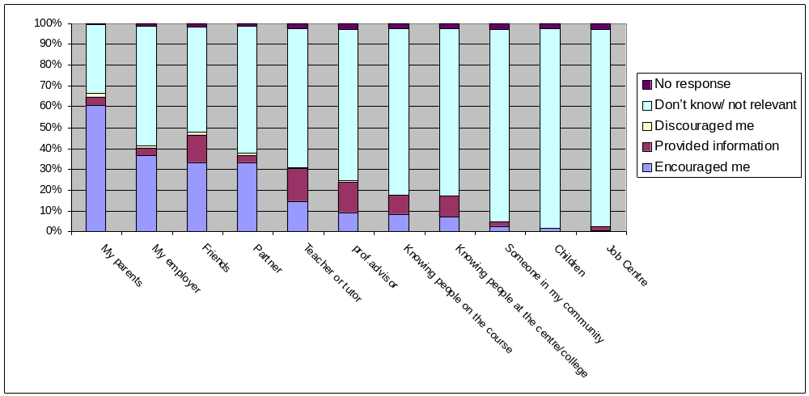

  - Experiences of and attitudes toward learning: A large majority of respondents reported characteristics associated with a positive learner identity: 80% of respondents agreed or strongly agreed they “enjoyed school” and over three quarters disagreed or strongly disagreed with the statement, “I find learning difficult”. Taken together with the relatively high levels of qualifications held by the majority of respondents (see table 5.4) their responses suggests that they are likely to have a positive learner identity. Nevertheless, a sizable minority (15%) reported not enjoying school or finding learning difficult (Table 6.3. and Graph 6.3.).

  - Motivations: respondents were strongly motivated by work, with two thirds “strongly agreeing” and a quarter agreeing that “I need to complete this course for the work I want to do”. Roughly three quarters were motivated by their enjoyment of the course and just under a third were motivated by wanting to help their family (Table 6.3. and Graph 6.3). Written comments, illustrated these responses, highlighting the role of employers, respondents’ aspirations and interests (see also written comments in paragraph 6.2) and the desire to help their families. For example:

Requirement of work.

Employer choose for me to attend.

The course provides an opportunity to progress my career with my current employer.

I work full time and my employer is sponsoring me to do the course to further my knowledge and career.

Chosen the course myself as always been interested in this field.

I want to provide a more comfortable life for my family. I love the subject I’m studying and I’m hoping that when my children are in full-time school I will be able to get a reasonably paid job.

I want to create a better life for my children.

Starting a family with my second child on the way and wanting to provide for them the best possible chance of achieving what they want,

  - Support and encouragement: A large majority of respondents were, or expected to be, supported and encouraged by others. Almost 80% of the friends of respondents had continued in post-school education and training; almost two thirds felt that if they were struggling with their course their family or partner would help them; over half felt that their family accepted that being on the course could sometimes disrupt family life and only a very small minority (4%) thought that if they found the course stressful, their friends would encourage them to stop. However, over a quarter felt that if they were struggling with their course their family or partner would not help them and a third disagreed or strongly disagreed that their family accepted that being on the course could sometimes disrupt family life (Table 6.3. and Graph 6.3.). Written comments on sources of inspiration, included large numbers which identified either knowing people working or studying in the field or people, most notably family and employers, who had encouraged them:

Friend of father was involved in construction industry and have been interested in built environment for years.

My brother provided most of the info for me.

It’s my friend who really inspired me to return to learning. He already works as a quantity surveyor and encourages me to do so.

I have many friends working in construction. Two of them are quantity surveyors and have given me a genuine interest in the job. I hope to go far

My friend in Leeds studies Construction Management part time and works for Barratt Homes. Talking to him made me interested in this course. Also I have done work with plumbers and as a labourer and decided I could do better than that.

Friends and family. Seeing people in the profession and wanting to do the same.

Met someone who had just finished the course. He was in great demand because of his skills/qualifications. Secure job with excellent salary. Enjoy work area.

I wanted to make a career for myself and have something to work to. My friend is doing the course and that’s how I found out about it.

My teacher in college recommended me to do this course after doing a civil engineering course.

I have always been interested in a good career which relates to a higher education. My family have always encouraged me to pursue my ambitions and my sister has informed and inspired me to pursue a career whilst I study part-time.

Fed up with being a secretary, got made redundant for a second time and decided to get into construction and housebuilding after I’d applied for a clerical position. The housebuilder agreed to train me to become a quantity surveyor and changed my job. Now on my way to becoming a full quantity surveyor.

My employer has encouraged me to complete this course to benefit my career.

My wife has been my rock. She finished her degree whilst pregnant and having out baby. Her dedication inspired me to start uni and stick at it!

Table 6.3. Experiences and attitudes toward education and training # of responses
Question | Strongly Agree | Agree | Do not know | Disagree | Strongly  Disagree | No response
I need to complete this course for the work I want to do | 114 | 46 | 7 | 4 | 1 | 0
I’m doing this course because I enjoy it | 30 | 98 | 24 | 13 | 6 | 1
I enjoyed school | 29 | 108 | 8 | 24 | 2 | 1
When I am struggling with my course, my family or partner would help me | 27 | 84 | 12 | 36 | 11 | 2
I am doing this course to help my family | 23 | 31 | 22 | 64 | 27 | 5
My family accepts that sometimes being on this course disrupts family life | 21 | 54 | 37 | 28 | 28 | 4
It helped me to know that people like me were doing this course | 20 | 77 | 47 | 18 | 7 | 3
Since I left schools none of my friends have continued in education or training | 5 | 14 | 17 | 73 | 61 | 2
Seeing my friends comes before my learning. | 3 | 16 | 35 | 86 | 29 | 3
I have started lots of courses but not finished them | 2 | 9 | 8 | 61 | 87 | 5
Housework has to come before my learning. | 2 | 8 | 11 | 85 | 64 | 2
I find learning difficult | 1 | 25 | 14 | 84 | 47 | 1
If I find the course stressful, my friends would encourage me to stop | 0 | 7 | 26 | 79 | 58 | 2
Graph 6.3. Experiences and attitudes toward education and training
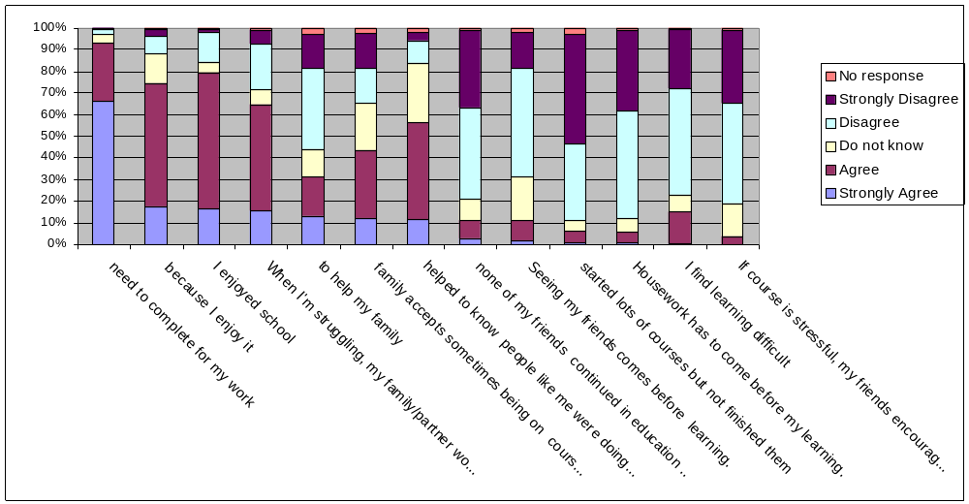
  - Were the responses of those who did not enjoy school different? We analysed the results for the 137 respondents who had enjoyed school separately from the 26 respondents who had not enjoyed school. There were some notable differences. Those who enjoyed school reported higher levels of encouragement from parents (66% compared to 48% for those who did not enjoy school), friends (36% compared to 20% for those who did not enjoy school) and professional advisers (12% compared to 0% for those who did not enjoy school), but interestingly, somewhat lower levels of encouragement from their partners (32% compared to 44% for those who did not enjoy school). Those who had enjoyed school also identified more people who had provided them with information (see Graphs 6.4. and 6.5 and Tables 6.4. and 6.5).

  - In addition, those who had not enjoyed school were less emphatic that if they were struggling with their course, friends and family would help them (only 8% strongly agreed, compared to 18% of respondents who had enjoyed school), and were much less likely to be doing the course because they enjoyed it (40% strongly disagreed or disagreed when asked, “I’m doing this course because I enjoy it” compared to only 8% of respondents who had enjoyed school). Interestingly, they were also less emphatic that they needed to complete the course for the work they wanted to do (only 50% strongly agreed compared to 68% of respondents who had enjoyed school) (see tables 6.6 and 6.7).

Graph 6.4. Sources of encouragement and information for those who enjoyed school

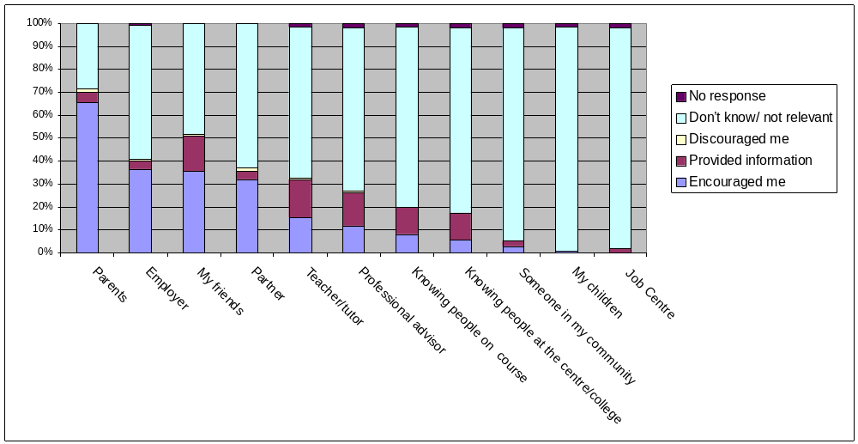

Graph 6.5. Sources of encouragement and information for those who did not enjoy school

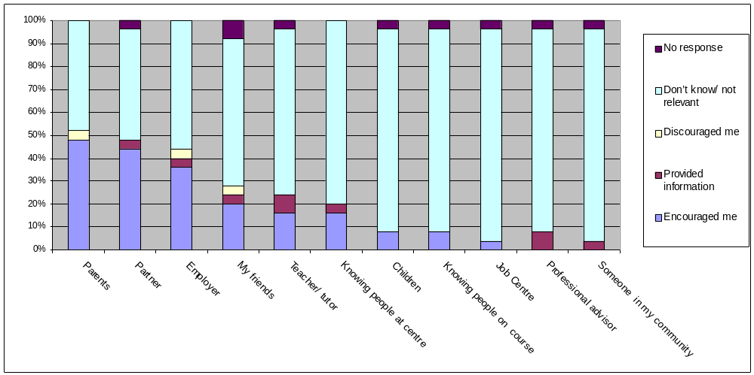

Table 6.4. Sources of encouragement and information for those who enjoyed school
 | Encouraged me | Provided information | Discouraged me | Don’t know/ not relevant | No response
My parents | 90 | 6 | 2 | 39 | 0
My employer | 50 | 5 | 1 | 80 | 1
My friends | 49 | 21 | 1 | 66 | 0
My partner | 44 | 5 | 2 | 86 | 0
Teacher or tutor | 21 | 23 | 1 | 90 | 2
A professional adviser (e.g. Careers Wales, social worker, YOT worker) | 16 | 20 | 1 | 97 | 3
Knowing people on the course | 11 | 16 | 0 | 108 | 2
Knowing people at the centre/college | 8 | 16 | 0 | 110 | 3
Someone based in my community (e.g. a youth or community worker) | 4 | 3 | 0 | 127 | 3
My children | 1 | 0 | 0 | 134 | 2
The Job Centre | 0 | 3 | 0 | 131 | 3

Table 6.5. Sources of encouragement and information for those who did not enjoy school
 | Encouraged me | Provided information | Discouraged me | Don’t know/ not relevant | No response
My parents | 12 | 0 | 1 | 12 | 0
My partner | 11 | 1 | 0 | 12 | 1
My employer | 9 | 1 | 1 | 14 | 0
My friends | 5 | 1 | 1 | 16 | 2
Teacher or tutor | 4 | 2 | 0 | 18 | 1
Knowing people at the centre/college | 4 | 1 | 0 | 20 | 0
My children | 2 | 0 | 0 | 22 | 1
Knowing people on the course | 2 | 0 | 0 | 22 | 1
The Job Centre | 1 | 0 | 0 | 23 | 1
A professional adviser (e.g. Careers Wales, social worker, YOT worker) | 0 | 2 | 0 | 22 | 1
Someone based in my community (e.g. a youth or community worker) | 0 | 1 | 0 | 23 | 1

Table 6.6. Experiences and attitudes toward education and training for those who enjoyed school
Question | Strongly Agree | Agree | Do not know | Disagree | Strongly  Disagree | No response
I need to complete this course for the work I want to do | 93 | 34 | 6 | 4 | 0 | 0
I enjoyed school | 29 | 108 | 0 | 0 | 0 | 0
I’m doing this course because I enjoy it | 26 | 79 | 20 | 8 | 3 | 1
When I am struggling with my course, my family or partner would help me | 25 | 69 | 9 | 24 | 9 | 1
My family accepts that sometimes being on this course disrupts family life | 17 | 41 | 25 | 24 | 27 | 3
I am doing this course to help my family | 17 | 27 | 18 | 49 | 24 | 2
It helped me to know that people like me were doing this course | 16 | 65 | 38 | 12 | 4 | 2
Since I left schools none of my friends have continued in education or training | 5 | 12 | 11 | 54 | 53 | 2
Seeing my friends comes before my learning. | 3 | 14 | 30 | 65 | 24 | 1
I have started lots of courses but not finished them | 2 | 7 | 7 | 46 | 72 | 3
I find learning difficult | 1 | 18 | 6 | 69 | 42 | 1
Housework has to come before my learning. | 1 | 5 | 9 | 66 | 55 | 1
If I find the course stressful, my friends would encourage me to stop | 0 | 4 | 21 | 60 | 51 | 1
Table 6.7. Experiences and attitudes toward education and training for those who did not enjoy school
Question | Strongly Agree | Agree | Do not know | Disagree | Strongly  Disagree | No response
I need to complete this course for the work I want to do | 13 | 11 | 1 | 0 | 1 | 0
I am doing this course to help my family | 5 | 3 | 2 | 10 | 3 | 3
My family accepts that sometimes being on this course disrupts family life | 4 | 10 | 6 | 4 | 1 | 1
I’m doing this course because I enjoy it | 4 | 13 | 2 | 5 | 2 | 0
It helped me to know that people like me were doing this course | 3 | 11 | 3 | 5 | 3 | 1
When I am struggling with my course, my family or partner would help me | 2 | 12 | 1 | 8 | 2 | 1
Housework has to come before my learning. | 1 | 2 | 2 | 11 | 9 | 1
I enjoyed school | 0 | 0 | 0 | 24 | 2 | 0
I have started lots of courses but not finished them | 0 | 1 | 1 | 11 | 11 | 2
Since I left schools none of my friends have continued in education or training | 0 | 2 | 4 | 12 | 8 | 0
I find learning difficult | 0 | 6 | 4 | 12 | 4 | 0
If I find the course stressful, my friends would encourage me to stop | 0 | 2 | 4 | 14 | 5 | 1
Seeing my friends comes before my learning. | 0 | 2 | 1 | 16 | 5 | 2

  - Were the responses of males and female respondents different? We analysed the results for the 136 male respondents separately from the 26 female respondents, to see of there were any notable differences. We were particularly interested in exploring whether the people who had encouraged them or provided them with information were different. We found that female respondents were more likely to feel they were encouraged by friends (54% of female respondents compared to 29% of male respondents), their partner (50% of female respondents compared to 31% of male respondents) and their children (38% of female respondents compared to 1% of male respondents), but less likely to feel encouraged by their parents (50% of female respondents compared to 61% of male respondents) (see Tables 6.8 and 6.9 and Graphs 6.8. and 6.9).

  - We also found that male respondents were more likely to be provided information by their friends (15% of male respondents compared to 0% of female respondents), professional advisers (15% of male respondents compared to 0% of female respondents) and knowing people on the course (10% of male respondents compared to 4% of female respondents). However, male respondents were less likely to be provided information by their employer (4% of male respondents compared to 15% of female respondents) or people based in the community (2% of male respondents compared to 12% of female respondents) (see Tables 6.8 and 6.9 and Graphs 6.8. and 6.9).

Table 6.8. Sources of encouragement and information for female respondents
 | Encouraged me | Provided information | Discouraged me | Don’t know/ not relevant | No response
My parents | 14 | 0 | 0 | 12 | 0
My friends | 13 | 2 | 0 | 11 | 0
My employer | 13 | 0 | 0 | 13 | 0
My partner | 10 | 0 | 1 | 15 | 0
Teacher or tutor | 7 | 4 | 0 | 15 | 0
A professional adviser (e.g. Careers Wales, social worker, YOT worker) | 2 | 4 | 1 | 19 | 0
My children | 1 | 0 | 0 | 25 | 0
Someone based in my community (e.g. a youth or community worker) | 1 | 1 | 0 | 24 | 0
Knowing people at the centre/college | 1 | 3 | 0 | 22 | 0
The Job Centre | 0 | 1 | 0 | 25 | 0
Knowing people on the course | 0 | 2 | 0 | 24 | 0

Graph 6.8. Sources of encouragement and information for female respondents

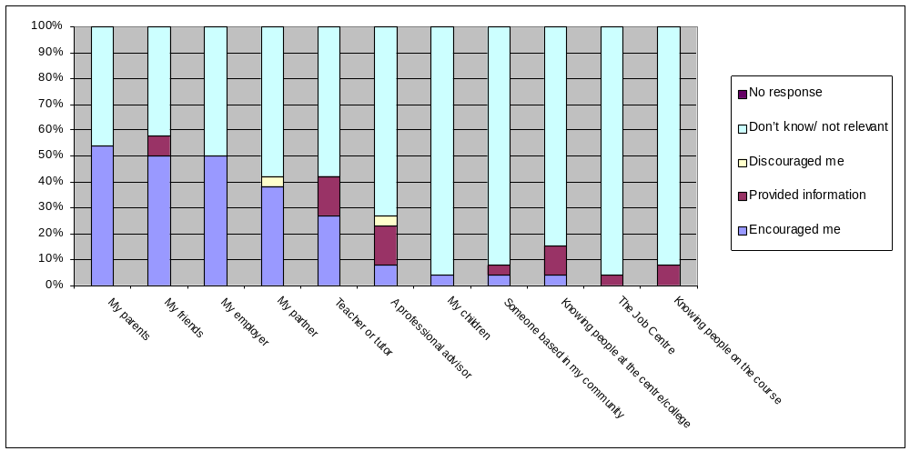

Table 6.9. Sources of encouragement and information for male respondents
 | Encouraged me | Provided information | Discouraged me | Don’t know/ not relevant | No response
My parents | 84 | 7 | 3 | 43 | 1
My employer | 46 | 5 | 2 | 83 | 1
My partner | 42 | 6 | 1 | 87 | 1
My friends | 39 | 21 | 2 | 73 | 1
Teacher or tutor | 18 | 22 | 1 | 94 | 1
Knowing people on the course | 14 | 14 | 0 | 108 | 1
A professional adviser (e.g. Careers Wales, social worker, YOT worker) | 13 | 21 | 0 | 101 | 1
Knowing people at the centre/college | 11 | 14 | 0 | 111 | 1
Someone based in my community (e.g. a youth or community worker) | 3 | 3 | 0 | 129 | 1
My children | 1 | 0 | 0 | 134 | 1
Job Centre | 1 | 2 | 0 | 132 | 1

Table 6.9. Sources of encouragement and information for male respondents

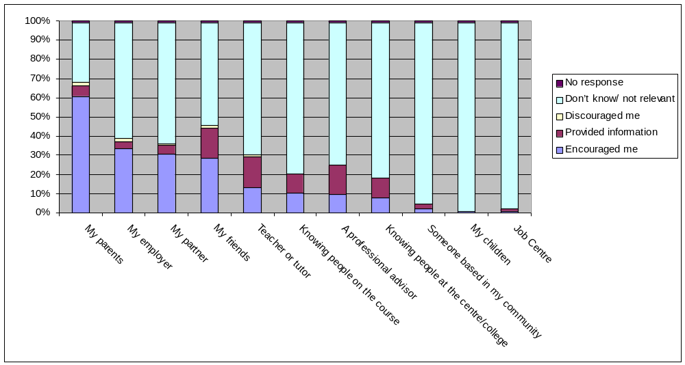
- Findings from the Interviews and focus group with learners and key informants

  - Profile of the learners: We interviewed six women and four men and 11 female learners took part in a focus group. They were selected as potential role models. All were under the age of 30, had low or no qualifications (below NQF Level 2) before returning to learning, had not enjoyed school, and lived in some of the most deprived communities in Wales, as defined by the 2005 Welsh Index of Multiple Deprivation. Crucially, with the support of projects such as Build It and Life Support, they were all now undertaking, and in some cases completing, courses in further and higher education.

  - Profile of key informants: Four of the ten key informants were working on the Build It project and two on the Life Support project. The projects are structured as pieces of action research, and by enabling project workers to work closely with participants over many years, have strong links to ethnographic research, in which a researcher immerses himself in the milieu of the subject for a lengthy period of time, watching their behaviour, listening to what they talk about and asking questions (cf. Bryman, 2001). The remaining four key informants were chosen as people who had worked, in roles such as Community First Coordinators, in the same communities as the learners we were particularly interested in (because the learners were considered potential role models who could inspire others).

  - Who or what inspired the learners? Five of the ten learners we interviewed attributed their decision to return to learning either principally or partly to one of the models of learning brokerage. Two were persuaded by professional learner brokers, such as project outreach workers, a third was encouraged by their partner and a fourth was “inspired” by their neighbour who had returned to learning themselves and a fifth by their sister. As they explained:

My sister gave me spirit. She shot off to uni. I didn’t want to be left behind stuck in a factory job.

  - Their responses were broadly echoed by the focus group, although participants tended to focus more upon on-going support rather than encouragement that had inspired them to start. Comments included:

My husband supports me. He would love to see me make it as a nurse.

My husband is with me all the way and very supportive. He is very encouraging and pushes me to carry on and not finish.

  - Four of these five learners we interviewed who were influenced by a learning broker had reached a point when they were open to encouragement or inspiration from another. For example, as two of them explained:

I was open to anything, I just wanted to get a good job, [I] didn’t really know what I wanted.

I was 20 when this [learning opportunity] came along. I was going nowhere ,just in and out of factories.

  - In contrast, the fourth needed more persuasion, as they explained they were “Stuck at home with two children” and it was only through the efforts of an outreach worker who “pushed her” when she didn’t really want to, that she returned to learning.

  - The remaining five learners we interviewed attributed their participation in learning to their own motivation, principally either to better themselves (financially or socially) or to help their children. For example, as one of the learners put it:

I got sick of factory jobs: packing chips in [name omitted], sitting soaking wet all day. I didn’t like that…..I just couldn’t do it no more, doing a crappy job for not much pay.

One learner succinctly summed the motivation up as “I want some of that”.

  - In addition to the ‘push’ of unrewarding “poor work”, with limited prospects, poor conditions and pay (cf. McDonald & Marsh, 2005), learners were motivated by the ‘pull’ created by seeing others earning more and acquiring status through their acquisition of qualifications. For example, as one learner commented:

“I could see others doing apprenticeships would get qualifications and experiences. That’s what I wanted to be, name on a piece of paper to say I was qualified.”

  - Is there evidence that learners inspire others? Two of the learners we interviewed identified people they had persuaded to return to learning. A further four were unsure, although they explained they actively encouraged others when they had the chance to. As one explained when they first started post-16 training themselves (as one of small group of learners), their friends would ask “what are you doing?” they explained that “some of our friends used to laugh, but after a while, seeing us achieving something , the interest comes” and the response changes to “‘can we get on?’” Another commented that “a good few of them are thinking about going to college or uni” but had not taken the first step and remained stuck in their routines and jobs in factory. Five of the key informants also discussed people they had inspired or helped.

  - Five of the key informants suggested that the biggest impact of learners success would be upon their own families. Indeed, as one of the learners explained:

I’m trying to encourage my brother. I wasted my opportunities. [You have] got to seize every opportunity.

  - These comments were echoed by the focus group, examples included:

My sister wants to have a go at going back to college to re-do an engineering course.

My mum keeps doing top-up courses: computing; management

I feel I portray a hard working image to my children, one which I hope they follow. My outlook on my children’s education has changed as I want them to achieve the best in order for them to be able to continue to achieve a career they want to be in.

My son actively wants to learn, I can help him and he looks up to me when I’m doing my work.

  - Three of the learners and four of the key informants we spoke to highlighted examples of a relatively passive model of influence. As one of the learners, and then one of the key informants put it, when describing the impact of learners’ success in qualifying in trades such as plastering and carpentry:

I’ve had people come up to me, ‘how much you earning? [sic] How much will you [when you’re qualified]?...got people saying I’m going to do a carpentry course, I’m like, ‘do it’.

The boys in the Bute [pub] has seen that he has got a life, got a job, they can see this and want a piece of it. People been asking [name omitted] if their boys could join the course.

  - The interviews strongly suggested that envy for others with money, rewarding jobs and status, might be a powerful motivator, but they also suggested it created a relatively narrow ripple of influence, in which learners’ success in one course made them trailblazers who encouraged others to try to follow in their footsteps. However, if those inspired could not follow in their footsteps, because for example the course was not running, the ripple effect would dissipate. One interviewee suggested that this reflected the limits of people’s experience and the boundaries of their comfort zone. Our research supports this, as we found little or no evidence that it translated into a more general interest in returning to learning.

  - One key informant suggested the narrowness of the ripples of influence from those who had succeeded in learning reflected the narrowness of many people’s experiences. They highlighted how, for example, young people wanted to work in the community centre, as “that’s the limit of their world, the limit of their experience”. In a similar vein, other key informants talked about how many young people wanted to become youth workers, as this was one of the few non-factory jobs they saw people their own age doing in their community.

  - Did they know of role models in the community? Although one of the learners we interviewed identified someone in their community who had “inspired” them, none were able to identify other people in the community who they felt inspired others. Three of the male respondents identified people “who’ve made money” (or similar) as people they looked up, rather than those who had succeeded through learning.

  - Are there negative role models? None of the learners we interviewed identified negative role models as such, although a number knew or knew of people who had, for example, a degree and were now stacking shelves.

  - Interestingly, there was some, albeit limited, evidence that a learners’ success may, in some circumstances, de-motivate others. For example, one of the key informants discussed their experience of progressing from their access course to a degree, which they had found difficult. As they explained “you assume wrongly that everyone else is doing fine” and that “seeing other people doing well is intimidating.” They described their post-graduate studies as a “real nightmare” , because they “felt too thick” until as they explained: “This one girl, I spoke to her, I went ‘here we go, another day’, she said ‘are you finding it difficult?’” They explained that this “three minute conversation” had been the turning point for them; knowing they were not the only one who was struggling.

  - The key informant linked their own experiences to the dynamics of groups of learners they had worked with, and the ways in which the confidence that some learners projected, intimidated others even when their standard of work was no better. They suggested that much depended on whether the projection of success was a way of establishing superiority over other, which, in some cases, involved putting others down, or whether it reflected a genuine ability, which could inspire others when, for example, a learner actively sought to help others without patronising them or when it fostered competition between learners.

  - Although not ‘role models’ as such, it is worth noting that a number of the key informants identified how family had discouraged people from either accessing or continuing in their learning. As one explained:

I supported a young girl to do youth work ….[she] volunteered a lot, was really up for it…went on a course, did a residential, and one or two weeks near the end, she quit….and never came back….Basically [her] family were stopping her doing it - becoming educated – they didn’t do the ‘school thing’…[asking her] ‘why are you doing this?’ None of her sisters or brothers went down this route and she felt like an outcast from her family.

  - This was echoed by a number of comments made by women in the focus group. Examples included:

My husband and father don’t support me on this, they think I shouldn’t leave the house.

My partner has always encouraged me to learn but also expected the house to be gleaming and to give him lots of attention. He did not realise how much work is involved in doing a nursing degree and we did split up for a while.

My partner and I split up…. He wasn’t supportive of me when I needed to study and perhaps it was for the best. He was proud of my achievements but because studying took up so much of my time perhaps he felt neglected.

  - One of the learners we interviewed also discussed how his peers had encouraged him to give up and questioned why he was learning. Indeed, as he put it before he returned to learning he was like:

“F’ing college. I was one of the those people [who said] ‘why do you want to go there? Like going back to school. What do you want to do that for, I’m earning this.’”

  - There is some evidence that this may represent a defensive reaction, in which friends in similar circumstances will actively seek to discourage a learner or even attempt to sabotage their efforts, so that they do not leave the rest of the group behind. Similarly, fathers my be reluctant to see their sons achieve more than themselves, potentially challenging their status and self-image (Pers. Comm.. Sarah Lloyd-Jones).

  - For the young men in particular, seeing friends earning money provided a powerful motivation to prioritise work over training. As three of the learners put it:

I went straight to college [after school], but my mates got jobs and I felt I needed money. I flunked out. Seems stupid now….[but then] seeing all your mates, [who] seem to have all the money in the world.

Most of my friends went straight to work. It was the norm: what factory were you in? how much you earning? [sic]

I ended up on the factory. Monkey work, but its money at the end of the day. Get paid and go out on the lash.

  - What are the conditions for influence? The most important conditions was visibility, knowing of and about potential role models. Interviews with both learners and key informants suggested that the ‘communities’ they lived in were composed of multiple smaller communities, with few links between them. Their lives were restricted to narrow social groups, so even where there were people with higher level qualifications living in the community, many of those with no or low qualifications were simply unaware of them. Indeed, some learners commented on how as their social circles changed, they had became aware of many more people in the community who had qualifications like them. The danger is that if successful learners move on and leave their friends behind, they themselves may become invisible.

  - Credibility and identification with both the messenger and the message they were carrying emerged as the other key issues. As one learner put, “if you don’t know someone you don’t listen to them.” One of the key informants identified with someone who had inspired them and helped motivate them after they had taken an initial step and returned to learning after a long break. They contrasted their influence with another tutor they had admired, but they had not identified themselves with, who had been far les influential as a consequence. Another key informant explained how they had questioned their ability to return to learning, asking

“could I do it? No one else believed I could. I was a young person growing up in [name omitted], why was I different? I didn’t like school…my parents were not supportive.”

  - For them the crucial factor in motivating them had been someone they looked up to who believed in them and their potential to succeed. Seven of the key informants we spoke to echoed and expanded upon this, highlighting the importance of support and encouragement to help sustain an initial spark of enthusiasm or interest, which could be easily snuffed out by the often daunting prospect of entering the unknown and returning to learn.

8. Conclusions

  - How does information about individual learners’ successes and failures spread in the community? The interviews and the surveys of learners in further and higher education both strongly suggest that information spreads by word of mouth. Partners, family, friends and employers emerge as the key sources of both encouragement and information. There is some evidence that they are more important for those with no or low qualifications and negative experiences of school because they are less likely to be either encouraged or access information from more formal learning brokers such as teachers and tutors, and Careers Wales Advisers. However, these more formal brokers, particularly teachers or tutors, are a relatively important source of information for those with qualifications at or above NQF Level 2 and/or have positive experiences of school.

  - Our findings on the importance of partners, family and friends are somewhat at odds with other, larger-scale research, which suggest that college and employers are more important sources of information for current learners (see paragraph 1.5) (Aldridge & Horrocks, 2003).

  - Our survey of learners in Higher Education provides evidence of the importance of employers, but still suggests that partners, family and friends are more important. Moreover, although we did not ask a direct question on the role of a college or university in providing information, and therefore we cannot be sure how important they are as sources, the written comments suggested they were for many respondents.

  - Employers and colleges they did not emerge as important sources of information in our interviews. All of those we interviewed were confined to “poor work”, jobs without training and with few prospects for progression, and had, for the most part, ended their participation in learning at 16, so their contact with these potential sources of information and encouragement was limited (cf. Lloyd-Jones, 2006; McDonald & Marsh, 2005).

  - It is less clear why employers or colleges did not emerge as important sources of information in our survey of learners in community and campus based further education who had low or no qualifications. As noted, we did not ask a direct question on whether the centre or college had provided information, which may offer some explanation. It is also possible that the low level of qualifications of many respondents and the relatively disadvantaged areas many lived in (with correspondingly restricted labour markets) (cf. David, et al, 2003), may have limited their contact with these potential sources of information and encouragement.

  - Overall, we are reasonably confident that our findings on the relative importance of formal and informal brokers are robust. Although, the numbers of responses in the survey of learners in community and campus based further education were low, the findings were consistent with the survey of learners in higher education, the focus groups and interviews and in other research (e.g. Holtom, 2007a; Lloyd-Jones, 2005).

  - The importance of partners, family and friends as sources of encouragement and information, suggest that learners’ access to information about learning opportunities is likely to be limited by the experience and beliefs of those close to them. The lower levels of encouragement from parents reported by female respondents in the survey of learners in the Faculty of Technology, a traditionally male dominated area of study, may provide a good illustration of the limits that the attitudes of significant others place upon potential learners. More broadly, given high levels of unemployment and economic inactivity and low levels of qualifications and participation in learning in the South Wales Valleys (David, et al, 2003), it cannot be assumed that the encouragement and information experienced by learners in these communities will be positive or accurate (cf. Lloyd-Jones, 2005; Gorard & Rees, 2002).

  - Moreover, the interviews suggest that the spread of information about success in these communities is often limited. Low levels of bridging capital mean that different groups of people in the community, in crude terms, those with and those without qualifications, often know little about each others successes and failures. In addition, although powerful, word of mouth can be an extremely inaccurate way of transmitting information, akin in some cases to ‘Chinese whispers’ (cf. Lloyd-Jones, 2005). Nevertheless, there was evidence that once they knew someone had succeed, they relied upon face to face communication with that person in order to find out more, which in principle should provide a more reliable mechanism for sharing information.

  - In our judgment those with no or low qualifications or who have not enjoyed school are less likely to access more formal brokers because they lack the social and emotional skills and knowledge necessary to make effective use of them. They may for example, lack confidence, have poor decision making skills or may not value their knowledge (cf. Holtom 2007b; Blenkinsop, et al, 2006; Lloyd-Jones, 2005). Moreover, there is some evidence that in contexts such as school, formal brokers such as teachers and careers advisers are more likely to encourage and advise those they believe will succeed, and may use experiences of school and educational attainment as an indicator of this (Furlong, 2004).

  - How can the role of learning brokers be strengthened? Although a majority of respondents were either encouraged or provided information by partners, friends and family, only a minority were encouraged or provided information by more formal brokers. This supports a number of reviews (e.g. McGiveny 1990, 2000) and initiatives such as the Community University of the Valleys Partnership and RISE (Holtom, 2007c; Yarnit, 2007), that suggest that more work is needed to reach our and engage non-traditional learners. We therefore recommend that consideration be given to

- Exploring how the capacity and motivation of teachers and tutors to act as learning brokers could be enhanced, by for example strengthening their knowledge of potential progression routes;
- Investigating ways in which those who already have credibility in the eyes of learners (such as teachers or tutors) could ‘lend’ or extend their credibility to others, such as Careers Wales advisors, by for example voicing their confidence in advisors’ ability and encouraging learners to use them;
- Strengthening collaboration between providers, so that progression routes are open to those who want to and providers are incentivised to broker access to other providers’ courses; and
- Considering how support can be made available on a pro-active, rather than reactive basis to the minority of learners who need it because their lack support from partners, family and friends and/or lack the social and emotional skills necessary to cope with problems, set-backs and crises in their studies and personal lives. This could increase the confidence of potential brokers that they would not be setting potential learners up to fail, encouraging them to raise learners’ aspirations.

  - How do people respond to the successes and failures of learners? The interviews and a large number of written comments in the survey of learners in higher education, suggest that learners who are seen to succeed, who earn more have “flash cars” and are in a position to buy their own homes, foster envy which provides a powerful motivation for others. Their status, as people with skills and qualifications (“the paper” to prove it) and their more rewarding jobs are also envied by those in factory work. It is possible that their success shatters the circle of limited experiences that their peers have grown up, exposing them to other possibilities (Cf. McDonald & Marsh, 2005). However, the extent to which this envy translates into increased rates of participation depends upon both access to good quality opportunities and their capacity to take advantage of those opportunities (HM Treasury, 2007; Schoon, 2006). For example, one of the written comments in the survey provides a poignant glimpse of how motivation, will not, of itself, suffice:

I am continuing into my second year of carpentry because my goal is to become a carpenter and to become self-employed in the future. I only hope that I can find a placement to continue []. I have been unsuccessful to date in finding a place, no-one seems to want to take anyone on. I think that colleges should ensure that all students have placements, I have known people who have had to give up their courses because of lack of apprenticeships. Maybe this could be sorted out in the near future.

  - People’s capacity to take advantage of learning opportunities depends upon a number of factors including the absence of barriers, such as a lack of money or transport that block people’s participation; the presence of academic skills such as literacy and numeracy and a range of social and emotional skills, such as self-motivation, self-awareness, empathy and the ability to handle relationships that have been conceptualised as “emotional intelligence” and that enable people to succeed as learners and persevere in the face of adversity (resilience); and practical support and encouragement from others, that can help them overcome barriers, cope with personal problems and crises of confidence (Jones, 2004; Goleman, 1995; McGiveny 1990).

  - The interviews also suggest that in groups of learners, the success of members of the group can encourage and inspire others, by both demonstrating that it is possible and by fostering competition. However, it can also intimidate members of the group and damage fragile learner identities and feelings of self-esteem, which can de-motivate other members of the group. Sharing experiences, so that members do not think they are the only ones who are struggling appears to help minimise this risk.

  - We did not find strong evidence that the failure of some learners to succeed can put others off. However, there is some evidence from other studies that suggests that their failure can be used to confirm or bolster non-traditional learners’ negative attitudes toward education (Furlong, 2004). Much depends upon the credibility of both the message and the messenger: people are more receptive to messages that come from people they trust and that are consistent with or confirm what they already think and ‘know’ (Lloyd-Jones, 2005). As a consequence, when exposed to the failure of someone they know, those who expect learning to be difficult, costly and of little value, are likely to have their views confirmed. Those who do not, who consider learning to be of value and ‘normal’ are more likely to discount it as an aberration or ascribe it to individual failure or bad luck.

  - In our judgement, the importance of the messenger’s credibility helps explain why teachers and tutors are more influential brokers than other professionals such as Careers Wales advisors. They have a relationship with and are known by learners and are likely to have credibility, as they have already proved themselves. In addition they have frequent face to face contact with learners making them very accessible.

  - Is there a ripple effect? There is some evidence from the surveys and stronger evidence from the interviews, that learning brokers can help engage those with negative ‘learner identities’ in learning. Both the interviews and surveys provide evidence of the effectiveness of informal learning brokerage and to a lesser degree, more formal brokerage. The interviews and a large number of written comments in the survey of learners in higher education, also provide evidence of more passive brokerage.

  - The interviews strongly suggest that while there is often a ripple effect when learners succeed, but that is quite limited in scope. Those who succeed can become trailblazers, who open doors and inspire others to follow in their footsteps. However, where this is not possible, because for example, the opportunity is no longer there or because they lack the capacity to exploit those opportunities (see paragraphs 8.12), the ripples dissipate.

  - How can the impact of role models be maximised? The key preconditions are visibility, credibility and identification. A number of interviewees suggested that the ripple effect couldn’t be taken for granted and needed to be actively cultivated. For example, as one key informant put it, without active outreach work, to raise awareness and understanding, successful projects can become just “one of those things going on down by the community centre”. We therefore recommend that consideration be given to:

- Developing pro-active attempts to raise the profile of success stories, through events such as community award ceremonies. This could also provide a way of reaching out to learners parents and partners (who are important sources of encouragement in their own right);
- Exploring how communities can develop bridging social capital, bringing those with no or low qualifications into contact with those who have prospered through learning; and
- Piloting a prospectus of local jobs, rather than just courses, This could provide information on salaries, accessibility (e.g. transport links) and entry requirements (e.g. qualifications), linking this to local providers offering the courses and qualifications required to access those jobs. So rather than offer a course that could lead to a range of jobs, you offer the job and then give information on the course needed for that job.

8.19. Because, once inspired, people also need access to opportunities and a range of academic, social and emotional skills in order to sustain their participation in learning, we recommend that consideration be given to:

- Strengthening progression routes so that opportunities are open to those who are inspired by a ripple effect; and
- Ensuring that support and encouragement is in place when and where a ripple effect is likely to occur, so that those who are inspired by it can be enabled to access and sustain their involvement in local opportunities. In a minority of cases, this is likely to mean going beyond offering information and encouragement, to actively helping potential learners solve problems and overcome barriers.

Bibliography

Aldridge, F. & N. Horrocks, 2003. Moving Forward: The NIACE Dysgu Cymru Survey On Adult Participation In Learning In Wales. Cardiff: ELWA

Aldridge,F, Cerys F. & and, Swati, N. (2007) : moving towards the learning country : survey of adult participation in learning in Wales 2007 Cardiff: NIACE Dysgu Cymru, also available online at http://niace.rcthosting.com/cms/media/2007-Eng.pdf [accessed 13th October 2007].

Bandura, A. 1997. Self-Efficacy: The Exercise Of Control. New York: W. H. Freeman And Company

Blenkinsop, S., McCrone, T., Wade, P. & Morris, M. (2006). How Do Young People Make Choices at 14 and 16? DfES Research Report RR773. Available online at http://www.dfes.gov.uk/research/data/uploadfiles/RR773.pdf [accessed 9th November 2007]

Bowman, H. T. Burden & J. Konrad. 2000., Successful futures? Community Views on adult education and training. York: JRF

Cornwall, R.J., 1999. The Significance Of Self-Efficacy In Enabling Or Disabling The Participation Of Long-Term Unemployed Adults In Lifelong Learning. Thesis (M.Phil.) - University Of Wales Swansea

David, R., Blewitt, N., Johnstone, E. & Grazier, S. (2003). The Socio-Economic Characteristics Of The South Wales Valleys In A Broader Context. Report For The Welsh Assembly Government Prepared by The Institute Of Welsh Affairs and The University Of Glamorgan.

Furlong, A. (2004) Cultural dimensions of decisions about educational participation
among 14-19 year-olds. Nuffield Review Working Paper 26 available online At:
http://www.nuffield14-19review.org.uk/files/documents44-1.pdf [accessed 9th November 2007]

Goleman, D. 1995. Emotional Intelligence: Why It Can Matter More Than IQ. New York: Bantam

Gorard, S. & G. Rees. 2002. Creating A Learning Society? Learning Careers And Policies For Lifelong Learning. Bristol: The Policy Press

Gorard, S., E. Smith, H. May, L. Thomas, N. Adnett & K. Slack. 2006. Review of widening participation research: addressing the barriers to participation in higher
Education. A report to HEFCE by the University of York, Higher Education Academy and Institute for Access Studies. Available online at http://www.hefce.ac.uk/pubs/rdreports/2006/rd13_06/barriers.pdf [accessed 20th August 2007]

Holtom, D. (2007a). Evaluation of the Community Progression Project (2005/08): Survey of Learners. Unpublished paper for the Department of Adult and Continuing Education, University of Wales Swansea

Holtom, D. (2007b). ‘Dancing Through the Gaps’: External Evaluation of the
Personal Support in Custody Pilot Projects- Final Report. Unpublished paper for the WAG

Holtom, D. (2007c). ‘What are the True Costs of Community Learning’. Contemporary Wales, Vol. 20, pp. 159-178

Jones, G. (2002) The Youth Divide: Diverging Paths to Adulthood. York: Joseph
Rowntree Foundation, also available online at http://www.jrf.org.uk/bookshop/eBooks/1842630814.pdf [accessed 24th September 2007]

Jones, G., 2005. The Thinking And Behaviour Of Young Adults, Literature Review For The Social Exclusion Unit. London: ODPM

Learning and Skills Council (LSC) (n.d.). ‘Envy and competition: Green eyed nation: skills are envied more than beauty’, LSC Press Release , downloaded from http://www.lsc.gov.uk/news/latestnews/news-090707-3.htm (21st October 2007)

Lloyd-Jones, S., 2005. A Map Of Transition In The South Wales Valleys. Thesis ., Phd. - University Of Wales Cardiff

Macdonald, R & J. Marsh. 2005. Disconnected Youth? Growing up in Britain’s poor Neighbourhoods. Houndsmill; Palgrave Macmillan

McGivney .V. (1990). ‘Education’s for Other People: Access to Education for Non-participant Adults’, Leicester: NIACE

McGivney, V. (2001). ‘Fixing or Changing the pattern: Reflection on widening adult participation in learning’, NIACE: Leicester

NIACE Dysgu Cymru, 2005, European funding and adult learning for Wales post 2006, http://niace.rcthosting.com/en/apagdetail.asp?Section=42&Ref=414#Full%20Report [Accessed, 2nd February, 2006]

Thomas, L., Quinn, J., Slack, K., Casey, L., Vigurs, K. & Flynn, N. (2004). Learning brokerage: Building bridges between learners and providers. London: LSRC. Also available online at http://www.lsneducation.org.uk/pubs/Pages/041625.aspx [accessed 18th October 2007]

Yarnit, M., D. Sachdev & R. Zwart. (2005). Understanding learning brokerage. London: Learning and Skills Development Agency

Yarnit, M. (2007). RISE: A Draft Proposal for the Second Phase 2008-2013. Unpublished paper for the RISE partnership

Welsh Assembly Government (WAG) (2006). The Learning Country: Vision Into Action. Cardiff: WAG, Available online at http://new.wales.gov.uk/topics/educationandskills/educationskillsnews/wales-action-on-learning?lang=en [accessed 18th September 2007]

Key informants

Susan Barrow, the Life Support Project, Rassau

Rhys Burton, Cwmni (Treherbert)

Steve Brookman, the Build It project, Treherbert

Mike Williams, the Build It project, Abertillery

Wayne Morris, the Build It project, Bryncynon

Les Davies, Fernhill Youth project

Tina Griffin, the Life Support Project, Rassau

Gary Foreman, Penywaun Enterprise Partnership

Darren Lewis, Communities first, Rassau

Theresa Purcell Cwmni (Treherbert)

The overall rate of adult participation rose from 42% in 2003 to 43% in 2007 (Aldridge, et al, 2007).
Adults in the highest socio-economic groups (A and B) are more than twice as likely to be learning as those in groups D and E. In addition there was a 5% increase in participation amongst groups ABC1 and a decline of 1% in groups C2DE, so the gap widened between 2003 and 2007 (ibid).
Thomas, et al, 2004 (p.5), provide an alternative categorisation of “very informal (suggestion and comment)” that roughly equates with our informal category; “more formal (providing advice)” which roughly equates with our formal category; and “strategic (working to change structures)” which represents a different type of learning brokerage that we do not address in this report.
Both projects worked with people aged 16 and over with no or low qualifications, helping them achieve qualifications at NQF Levels 2-5 in the fields such as plumbing, carpentry, brick-laying and nursing.
Other learners in similar circumstances have described similar experiences, in which the transition from community-based provision to campus-based provision has left them feeling isolated and alone. Many experience a crisis of confidence and feel like outsiders or interlopers who don’t fit in, but who can experiences turning points when they share their experiences with other learners and realise they are not alone (Pers. Comm.. Sarah Lloyd-Jones).
This provides a good example of how strong “bonding social capital”, that binds a group together, can limit people’s experience unless complemented by “bridging social capital” that links different groups of people.
The census data suggests large numbers of people in each of these small, deprived communities with qualifications at NQF level 6 or above. For example, the 2001 census found that 321 people in Treherbert, 8% of the working age population, and 135 people in Penywaun, 7% of the working age population, had qualifications at NQF level 6 or above.
The question was phased as “knowing people at the centre/college”, “encouraged me”, “provided information”, “discouraged me” or “Don’t know/not relevant”.
This was also reflected in a recent Learning and Skills Council sponsored ICM poll (LSC, n.d.).
Having a contractor (placement), is a precondition for progressing to NQF Level 2 on the Modern Apprenticeship programme.
That is to say, in this case, those with low or no qualifications and negative experiences of school.

